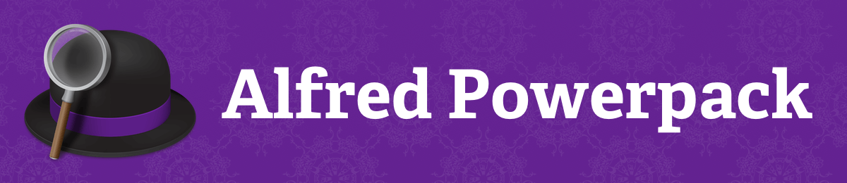

Thank you for buying an Alfred Powerpack license!

This is the license code you need to unlock the Alfred Powerpack functionality:

Email:

ihrthk@163.com

License Code:

A4SLZWY3NThiMzZiNzcyBQ9dcDqhit4ps22T7IctmpqgoMZfQS
iTEW9y1cjkLAwFJmhOxLmK3R/+iOMa3VdZCW9zktLOu+XW6yTj
P3Zdo1OY+EXiHWVKVIdLbMVgu3CmJgyefdFo3mLSUHweCQjXja
4CJnZrpcEALHtu53jcHthad7PEsIaZPapBr4AyUAKxQTw6LyI8

Copy and paste your license details above to the Alfred Powerpack preferences. If you are missing the Powerpack tab in the preferences, you are using the Mac App Store version. You'll need to download the latest version of Alfred from our website first.

Need help to get started with Alfred? Visit our help site for tutorials on using Alfred, as well as useful workflows, tips and tricks.

You can also find us on Twitter at @alfredapp to say hello.

Cheers,
Andrew and Vero

You purchased the Alfred Powerpack from Running with Crayons Ltd, a company registered in England and Wales (company number 7211061) at Lakin Rose, Pioneer House, Vision Park, Histon, Cambridge CB24 9NL, United Kingdom. For more information, visit https://www.alfredapp.com/

